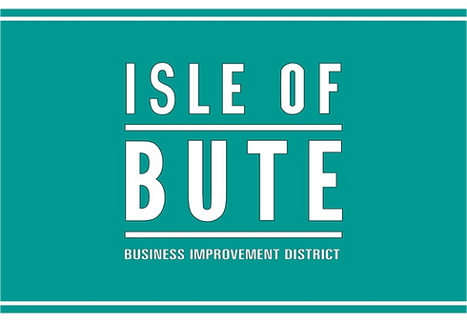
Event Support Scheme 2025: Application Form

All documents submitted with your application will be handled in strictest confidence.
Please email your submission and relevant document to the Project Manager - Phil Prentice - at info@butebid.com

Please Note: There is a strict annual budget for this scheme. Applications will be assessed on a first come, first served basis and must meet the scheme guidelines to be approved.

Details:

Name of organisation
Name of lead contact
First Name
Last Name
Email of lead contact
Sign up for news and updates
Telephone Number
What is the legal status of your organisation?
(If applicable - please give registration numbers eg Charity
Number/Company Number)
Tell us about your event - date(s), location and description
How many participants will benefit from the event?
How many attendees will benefit from the event?
Please describe what you require funding for.
Is it for general running costs or to add a specific element to your

event?
Give a summary of why you think there is a demand for your event
Provide supporting evidence where possible.
Give a summary of how your intend to publicise your event Please provide a marketing plan if you have one
Give a summary of the anticipated economic & social benefits to businesses in the IOB BID area.
Please provide supporting evidence for your summary with this application and show how you have derived your figures e.g. any market research you have done for this event or any reports from similar events you may have done.
What would happen to the event if your grant application is unsuccessful?
How will you know your project has been successful? Give details of methods you will use to evaluate it, particularly relating to the benefit to businesses on Bute.

Checklist
Please ensure you now upload a copy of the following where possible:
- A projected budget for the event.
- A projection of economic and social benefits to town.

- Previous financial year accounts (if applicable).
- Previous event reports including financial and other quantifiable outcomes (if applicable).
- Confirmation of permissions from relevant bodies that the event can take place - eg. police / council / landowners.
- Confirmation that all statutory requirements are met, particularly those relating to health and safety legislation and the Protection of Vulnerable Groups (Scotland) Act 2007.
- Details of other funding received or applied for.

Declaration
I confirm that the information provided in this application is true and accurate to the best of my knowledge. I have read and understood the Event Support Scheme 2025 Grant Guidelines issued by IOB BID Ltd., and agree to abide by the terms and conditions outlined, including:
- Use of funding solely for the approved event and eligible costs.
- Delivery of the event within the IOB BID area, or demonstrable benefit to BID businesses.
- Submission of a short post-event report, final attendance figures, and receipted invoices within 8 weeks of the event.
- Inclusion of the IOB BID logo on promotional materials and public acknowledgment of support.
- I understand that IOB BID may reclaim any funding if these conditions are not met or if the event does not proceed as described.
- I confirm that I have read and understood the IOB BID Ltd.’s Event Support Scheme Guidelines and consent to my information being used for this application.

Print Name: | Date: | Signature:

