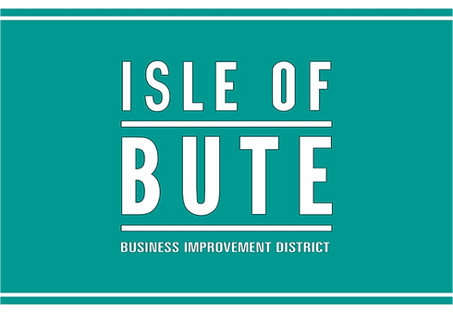

Event Support Scheme 2025: Grant Guidelines
IOB BID’s Event Support Scheme is designed to boost the number, quality and economic impact of events and festivals in the town. The scheme aims to:
- Encourage more year-round activity, especially during quieter months.
- Increase footfall and dwell time in the town centre.
- Drive additional spend with local businesses.
- Support event organisers to trial, grow or enhance events that benefit the Island.
This initiative is one way IOB BID reinvests levy income directly into the local economy, by supporting activity that attracts people and strengthens the town’s reputation as a place to visit, stay and spend.
What We’re Looking to Support
Applications should demonstrate a clear link to at least one of the following goals:
- Growing existing events: either in scale, duration or visitor engagement.
- Launching new events that serve a local audience or attract visitors.
- Increasing attendance or participation, including overnight stays.
- Improving the quality or professionalism of event delivery.
- Widening the appeal or marketing reach of an event.

Who Can Apply?
The scheme is open to:
- Local businesses, groups and voluntary organisations.
- Event organisers and producers.
- Community trusts, social enterprises or clubs.
- Individuals or collectives with a viable event plan.

To be eligible, the event must take place within the IOB BID area or demonstrate a direct and measurable benefit to businesses within it. Events taking place across multiple areas may still qualify if the BID-funded element supports activity within the town centre.
Events do not need to be free or public-facing, but and can be run for profit. Conferences, specialist gatherings and closed events are welcome if they can show benefit to the town’s business community (e.g. accommodation bookings, hospitality spend, local suppliers).

What Can Be Funded?
Grants can be used to support:
- Planning and delivery costs
- Infrastructure or equipment hire
- Marketing and PR
- Visitor experience improvements
- Added-value elements (e.g. evening programming, fringe activity)
- Capital items directly related to event delivery

IOB BID will generally fund up to 50% of the total event budge up to a maximum of £3,000.
We expect all other income - grants, ticket sales, sponsorship or volunteer time - to be clearly set out in your budget.
Only costs incurred after your funding award has been confirmed will be eligible for support. How to Apply
Applications can be made at any time using our Event Support Application Form.
Please include:
- A full budget (income and expenditure)
- A summary of expected outcomes: economic, social, and visitor impact
- Previous event reports or evaluations (if applicable)
- Confirmation of venue/landowner permissions
- Evidence of public liability insurance
- Confirmation of health and safety measures and legal compliance (e.g. licensing, safeguarding, PVG if relevant)
- Details of any other funding received or applied for

What Happens Next?
Applications are reviewed on a rolling basis and assessed by the IOB BID Board at regular meetings.

You will receive a decision within 7 days of the relevant meeting.
If successful, a formal award email will confirm the amount granted and any conditions.
In most cases, payment will be made after the event, upon submission of:
- A completed claim form.
- Receipted invoices.
- A short impact report, including final attendance figures, economic outcomes and business feedback.

Advance payment can be considered in exceptional cases, subject to Board approval.
Recognition and Follow-Up
We ask all supported events to:
- Include the IOB BID logo on promotional materials.
- Mention BID support in public communications and press.
- Submit a short post-event report within 8 weeks of delivery.

This helps us demonstrate value to our levy payers and supports future investment.
Need Help?
If you're not sure whether your idea is eligible, or if you'd like to discuss a proposal before applying, we’re happy to help.
We are particularly keen to support events that contribute to off-season activity, encourage repeat visits, overnight stays, use local services / supplier or support local economic resilience.
If you need help completing the form, please get in touch with your Project Manager:

Phil Prentice
info@butebid.com
07971 437732
